Lab03

Wniosek dotyczący Canny:

Detekcja krawędzi Canny dobrze pokazuje efekty skalowania. Przy powiększaniu krawędzie stają się grubsze, co potwierdza poprawne zwiększenie rozdzielczości. Przy pomniejszaniu krawędzie zanikają lub są cieńsze, co odzwierciedla utratę szczegółów. Canny jest szczególnie przydatne przy ocenie jakości powiększania, gdzie różnice nie zawsze są widoczne gołym okiem.

# Downscaling Results

## File: BIG_0001.jpg

# Downscaling Results

## Fragment 1 – Coords: [500, 2000, 900, 2400]

### Scale: 10%

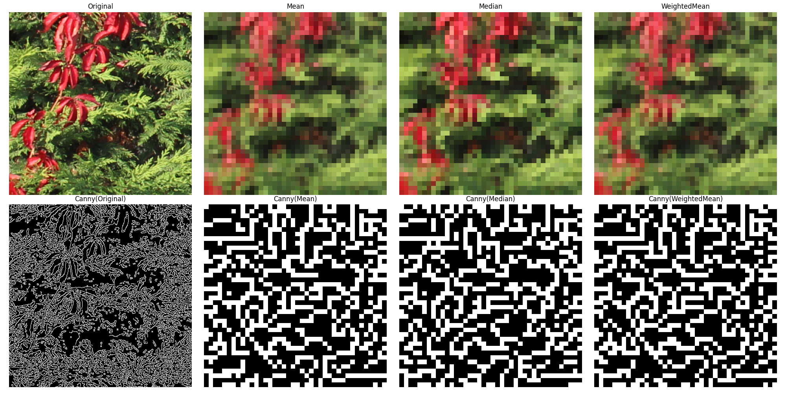

Mean: 0.12 seconds

Median: 0.13 seconds

WeightedMean: 0.15 seconds

### Scale: 5%

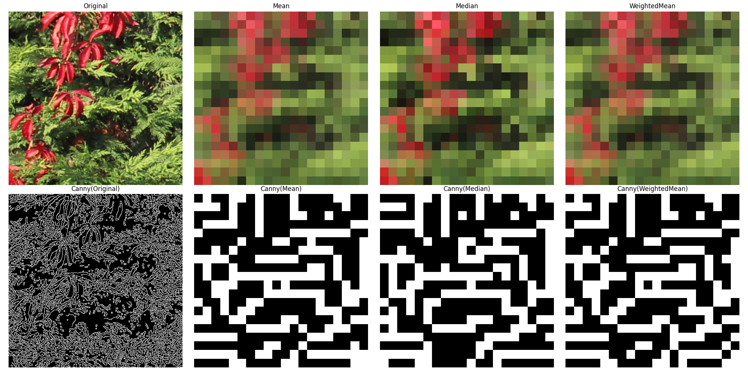

Mean: 0.03 seconds

Median: 0.05 seconds

WeightedMean: 0.04 seconds

## Fragment 2 – Coords: [1000, 1000, 1500, 1600]

### Scale: 10%

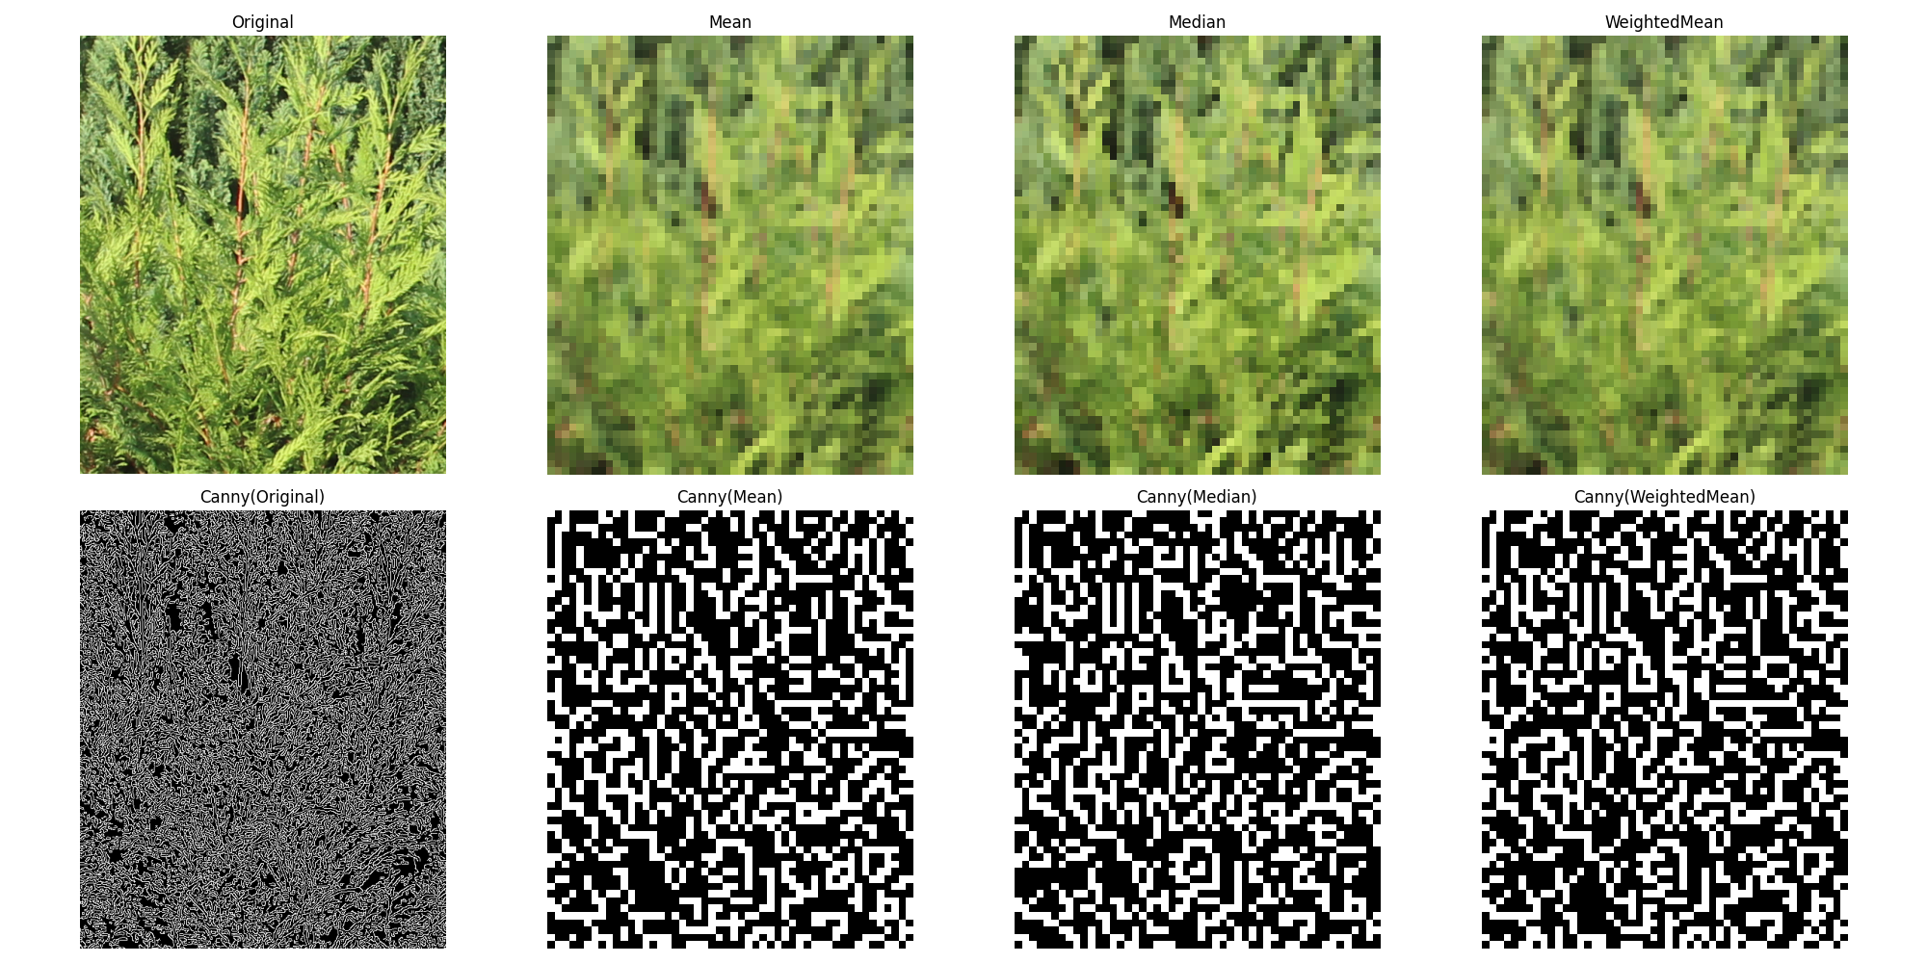

Mean: 0.21 seconds

Median: 0.25 seconds

WeightedMean: 0.31 seconds

### Scale: 5%

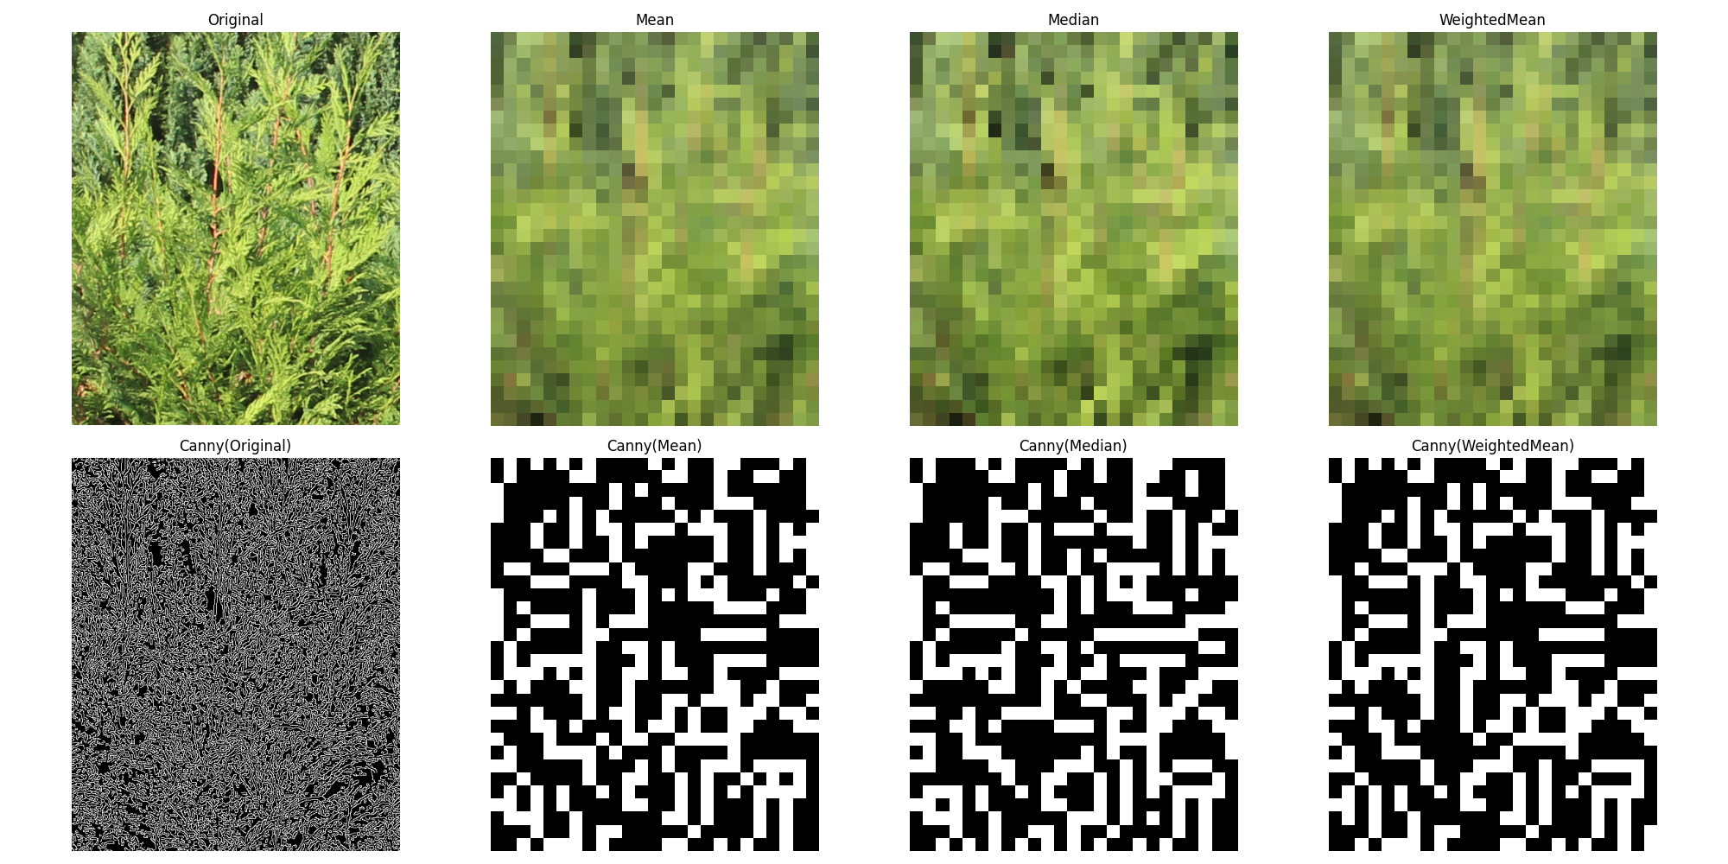

Mean: 0.05 seconds

Median: 0.06 seconds

WeightedMean: 0.08 seconds

## Fragment 3 – Coords: [3500, 600, 4000, 1200]

### Scale: 10%

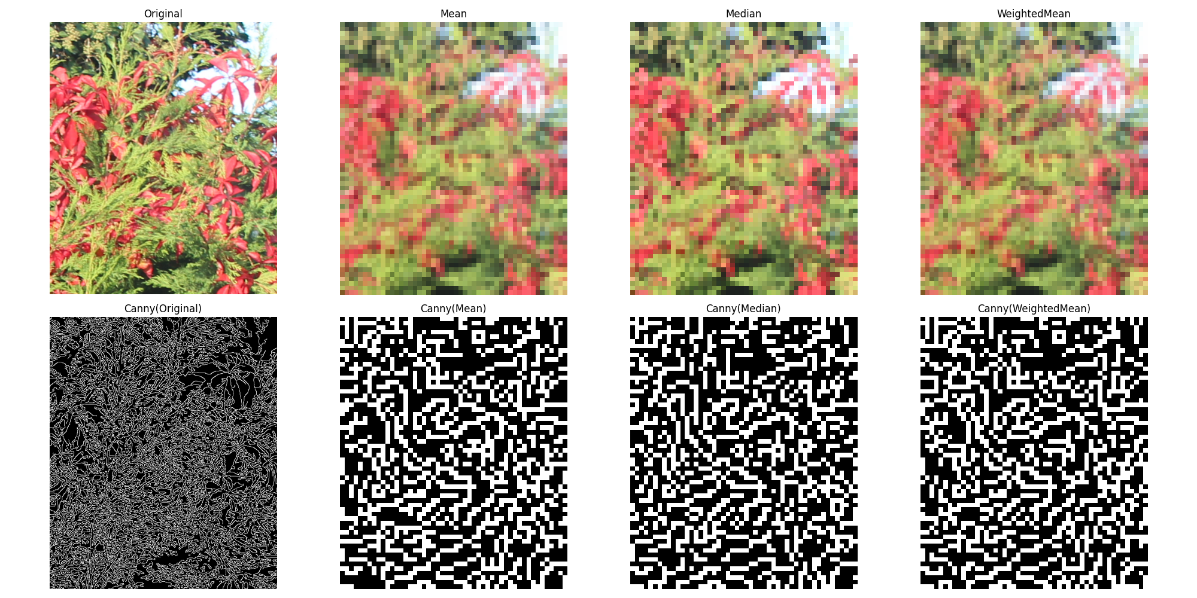

Mean: 0.17 seconds

Median: 0.28 seconds

WeightedMean: 0.24 seconds

### Scale: 5%

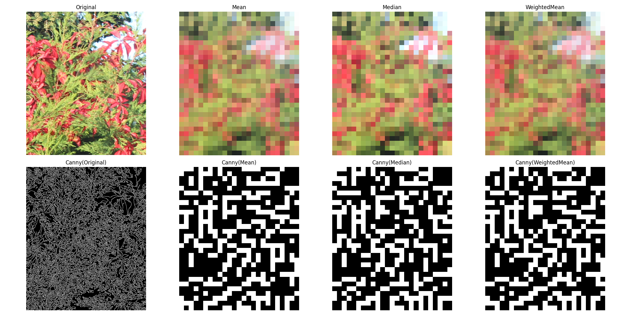

Mean: 0.06 seconds

Median: 0.09 seconds

WeightedMean: 0.08 seconds

## File: BIG_0002.jpg

# Downscaling Results

## Fragment 1 – Coords: [1000, 2400, 1600, 3000]

### Scale: 10%

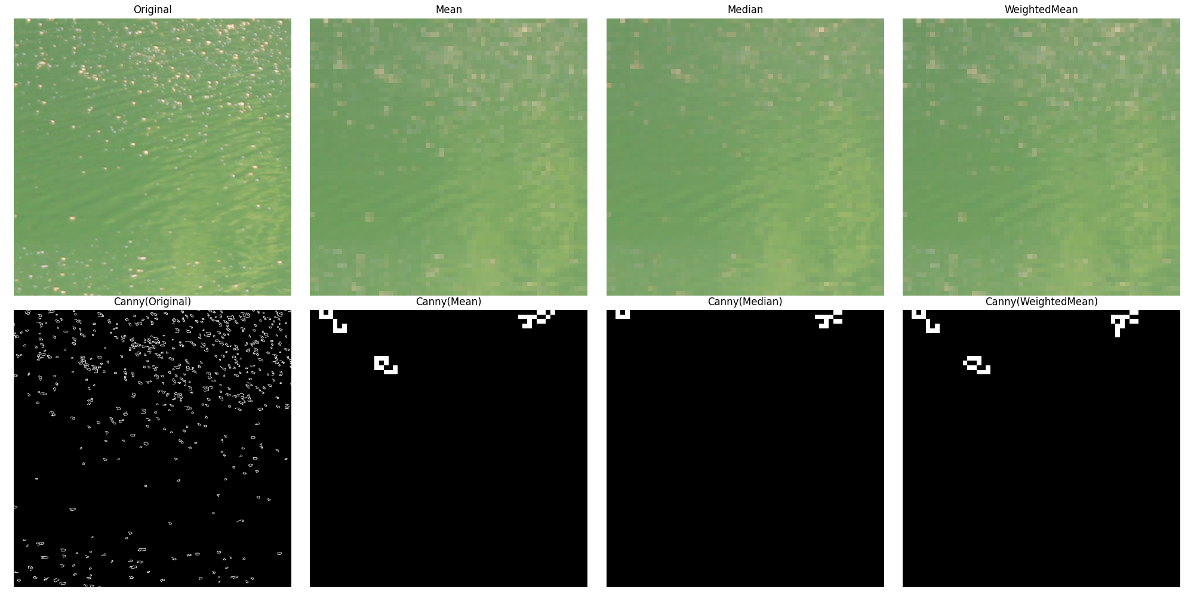

Mean: 0.20 seconds

Median: 0.30 seconds

WeightedMean: 0.33 seconds

### Scale: 5%

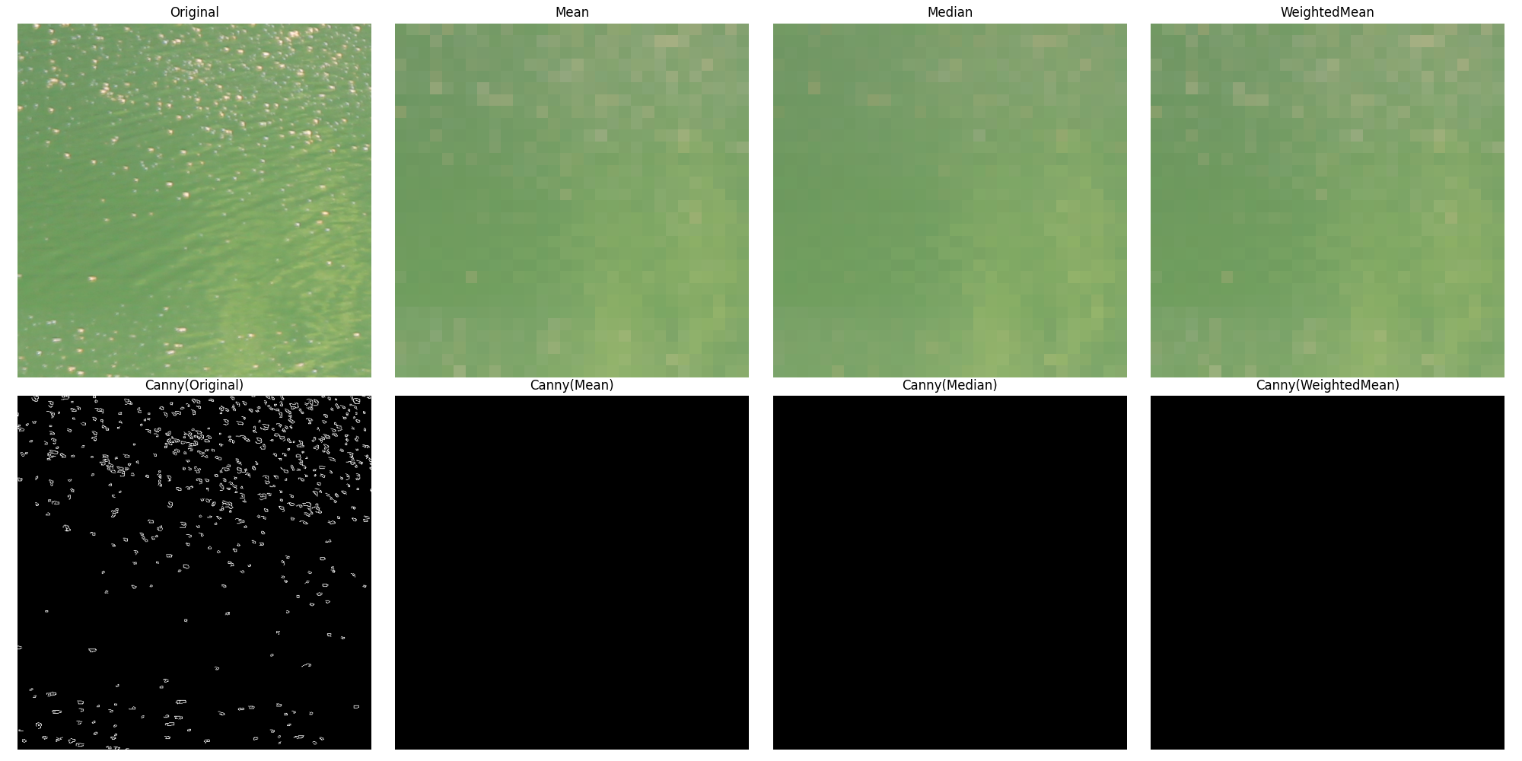

Mean: 0.09 seconds

Median: 0.09 seconds

WeightedMean: 0.08 seconds

## Fragment 2 – Coords: [800, 1200, 1400, 1800]

### Scale: 10%

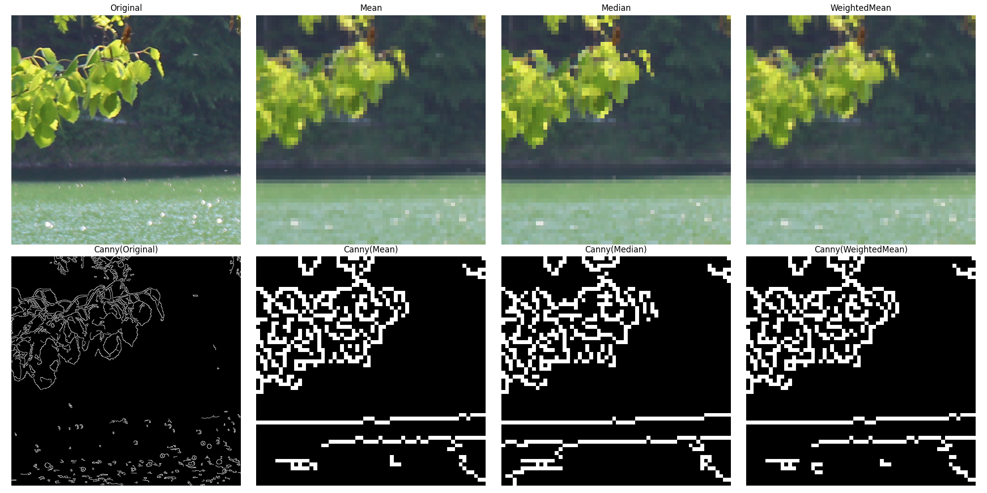

Mean: 0.22 seconds

Median: 0.28 seconds

WeightedMean: 0.29 seconds

### Scale: 5%

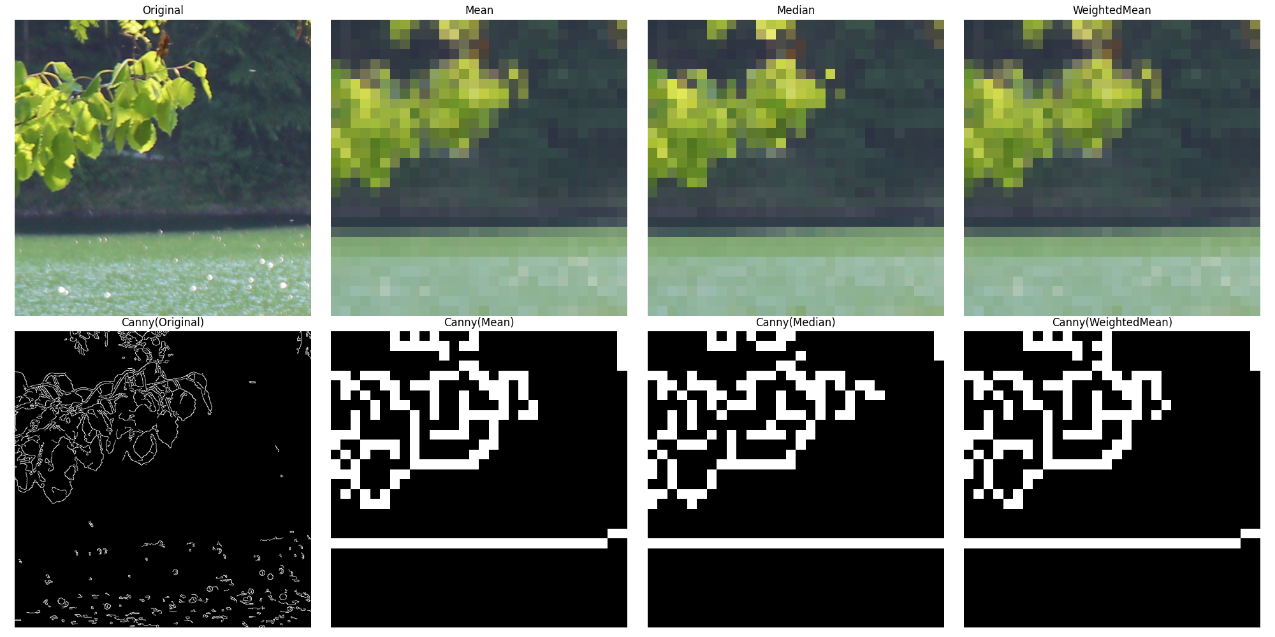

Mean: 0.06 seconds

Median: 0.08 seconds

WeightedMean: 0.07 seconds

## Fragment 3 – Coords: [3000, 1800, 3600, 2400]

### Scale: 10%

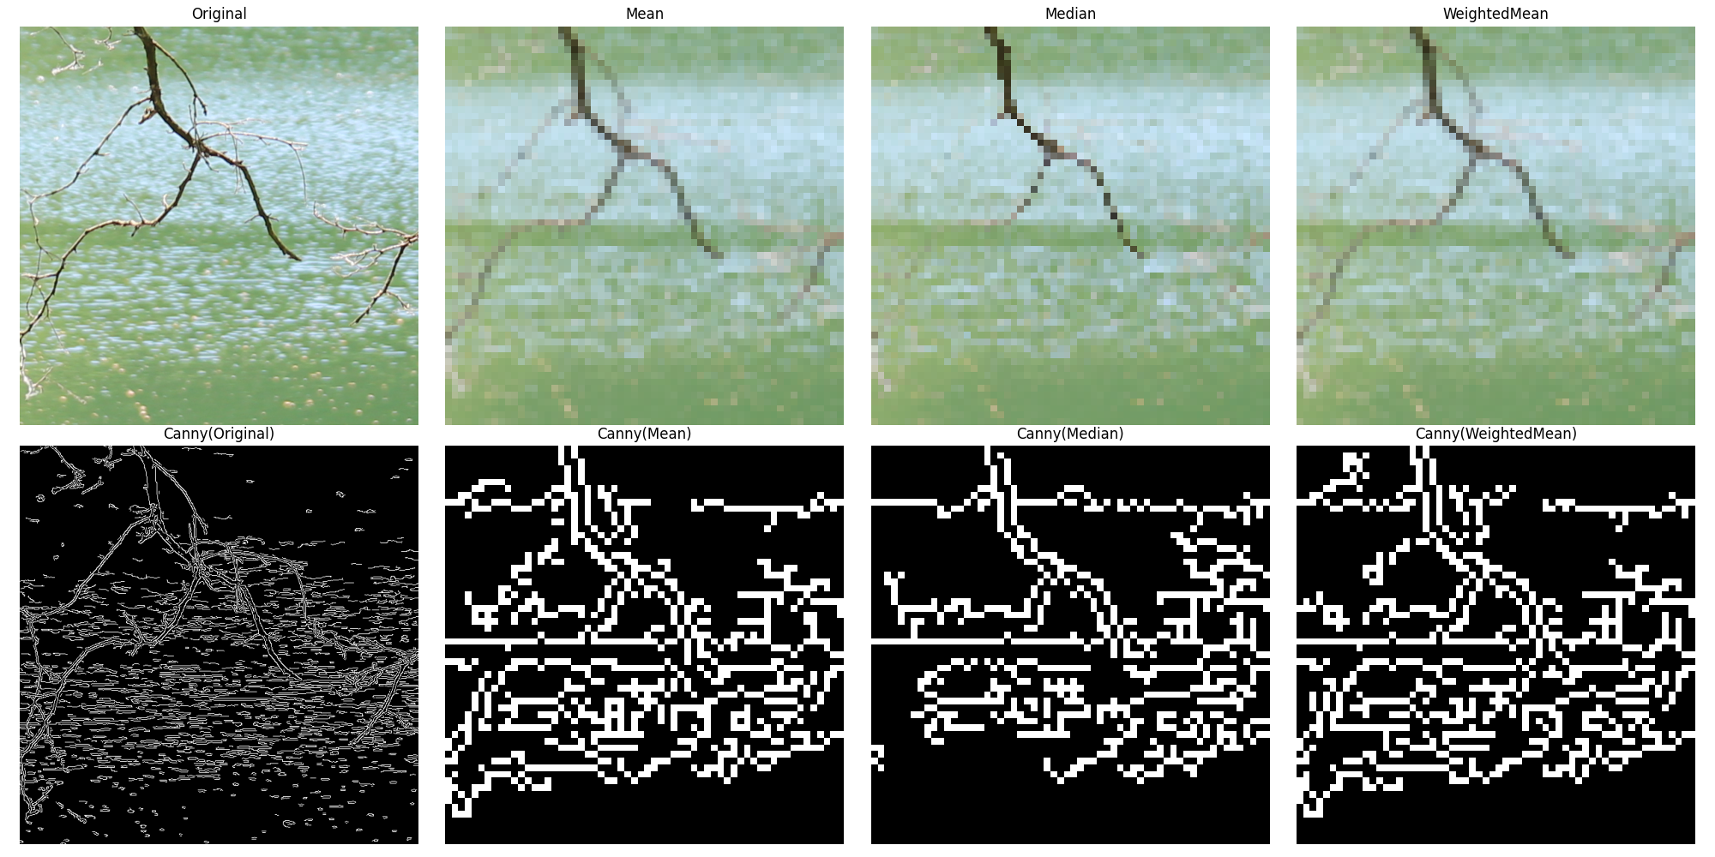

Mean: 0.19 seconds

Median: 0.29 seconds

WeightedMean: 0.34 seconds

### Scale: 5%

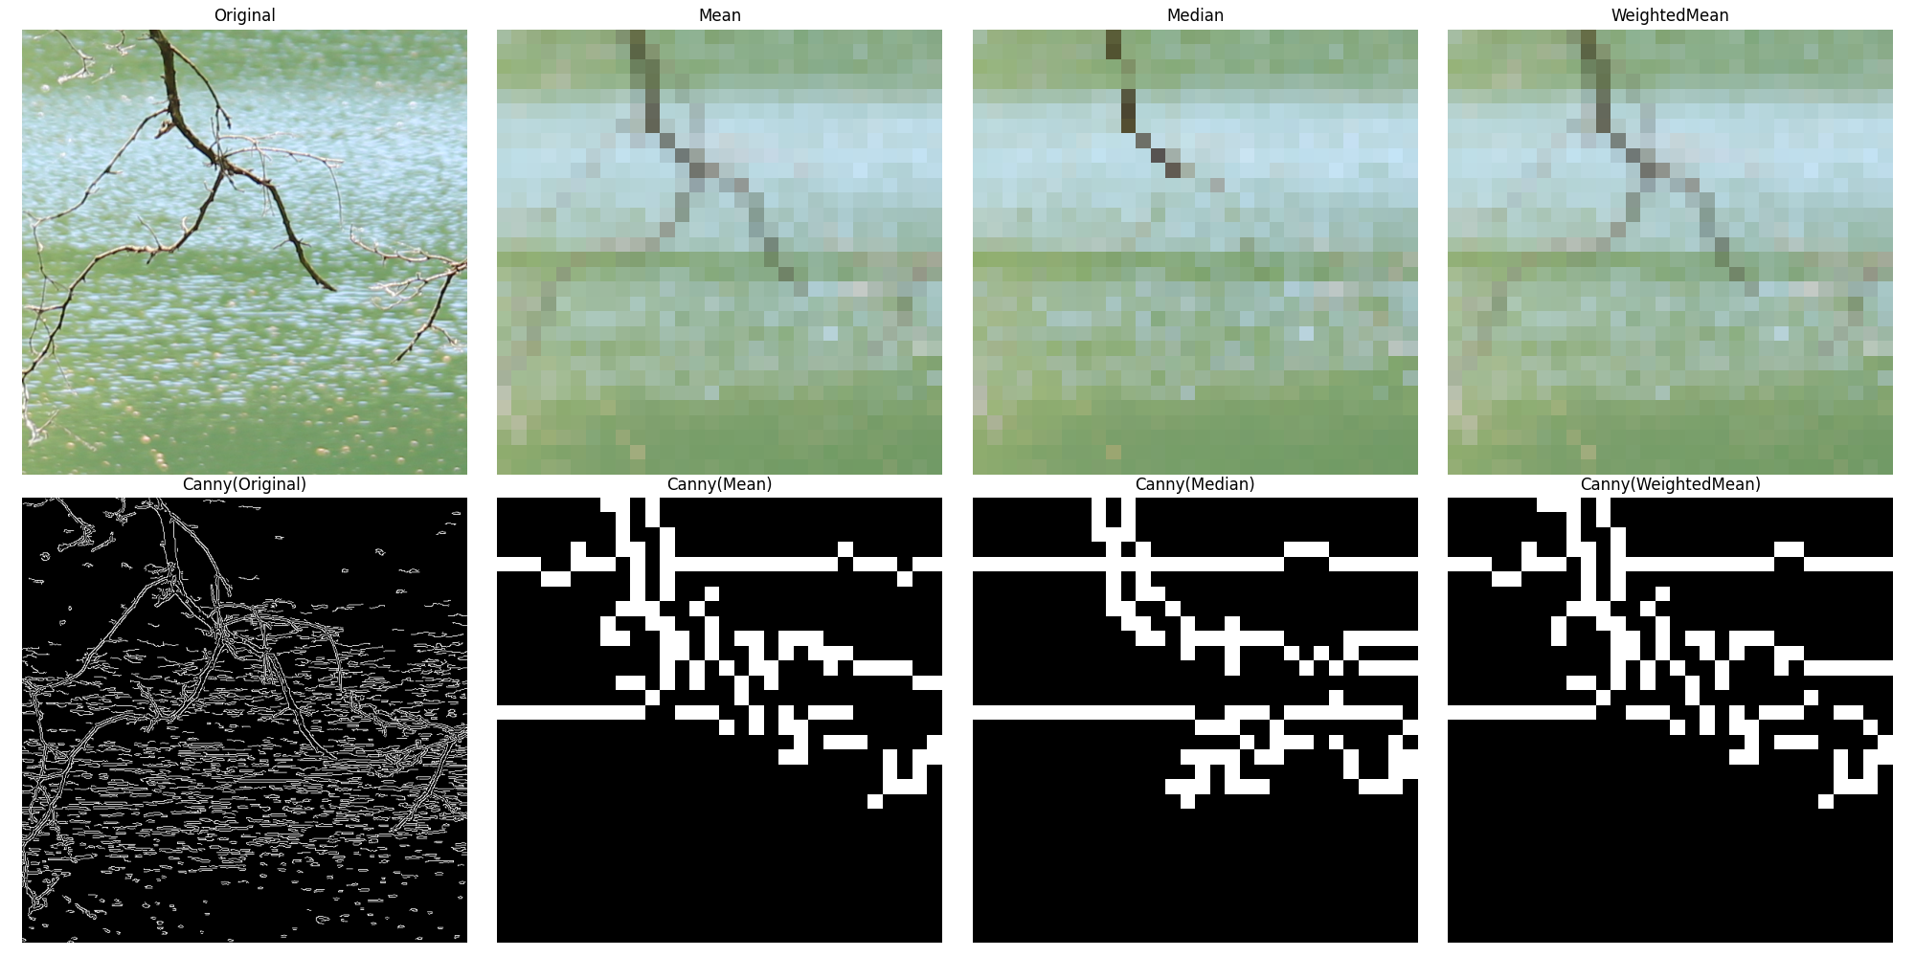

Mean: 0.08 seconds

Median: 0.08 seconds

WeightedMean: 0.10 seconds

## File: SMALL_0003.png

# Upscaling Results

## Scale: 200%

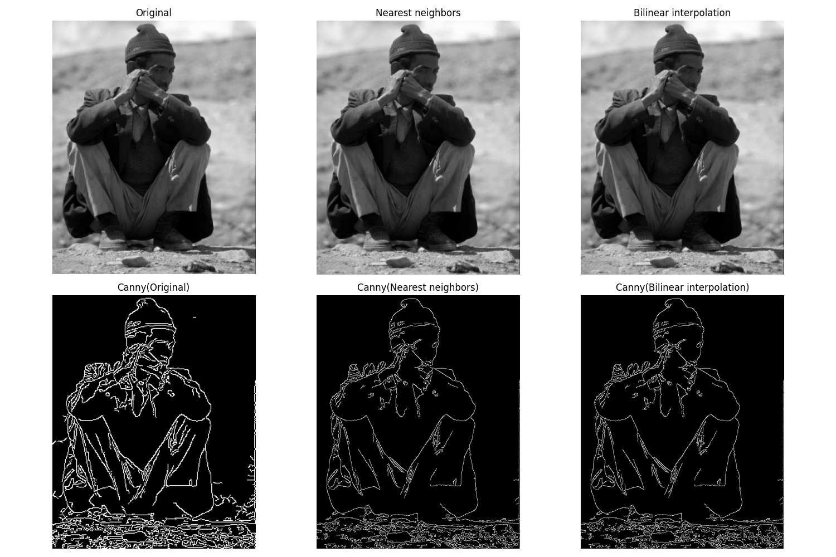

Nearest neighbors: 0.01 seconds

Bilinear interpolation: 0.09 seconds

## Scale: 500%

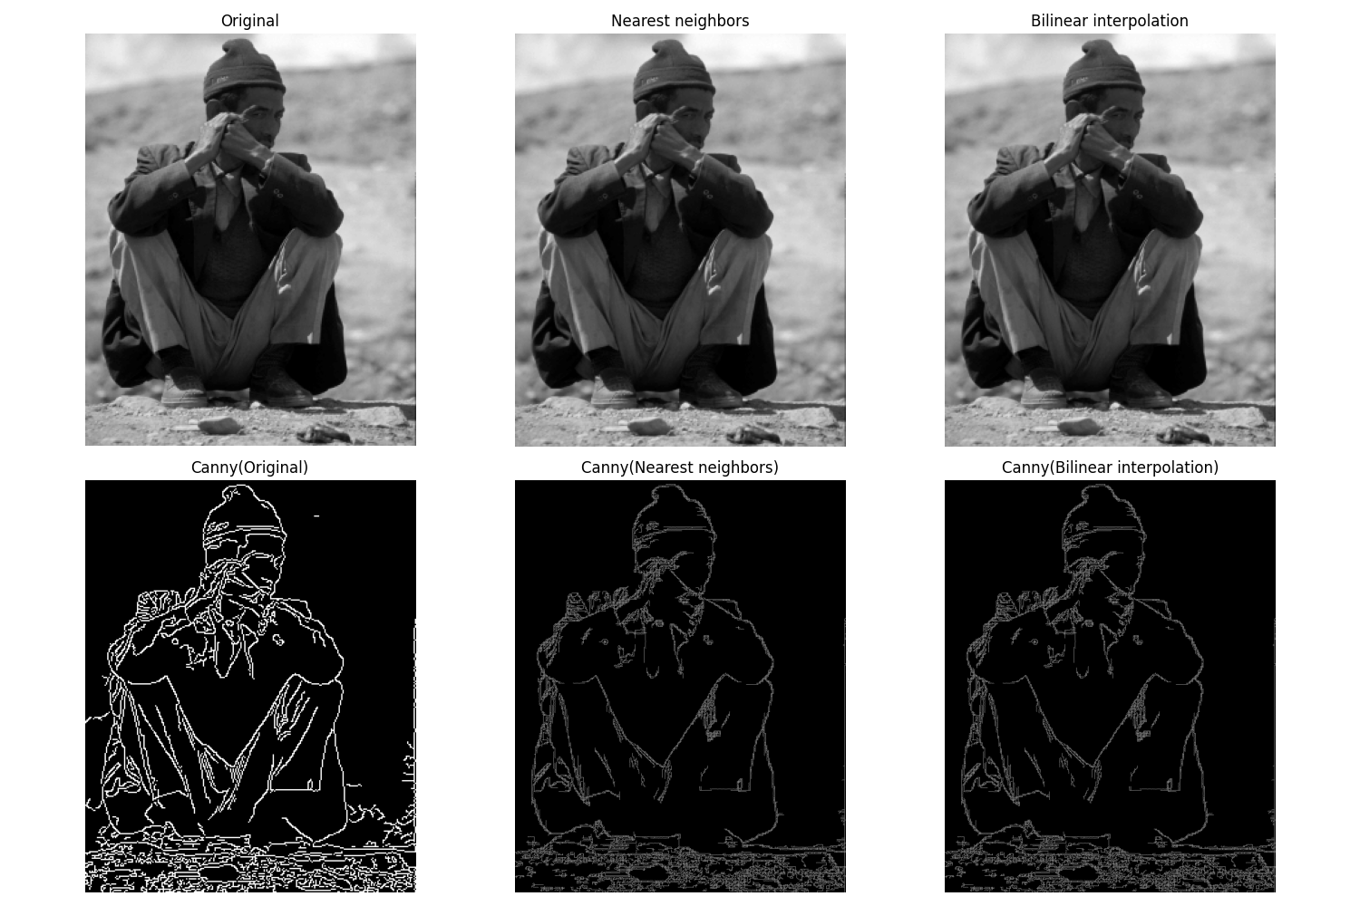

Nearest neighbors: 0.14 seconds

Bilinear interpolation: 0.68 seconds

## File: SMALL_0005.jpg

# Upscaling Results

## Scale: 200%

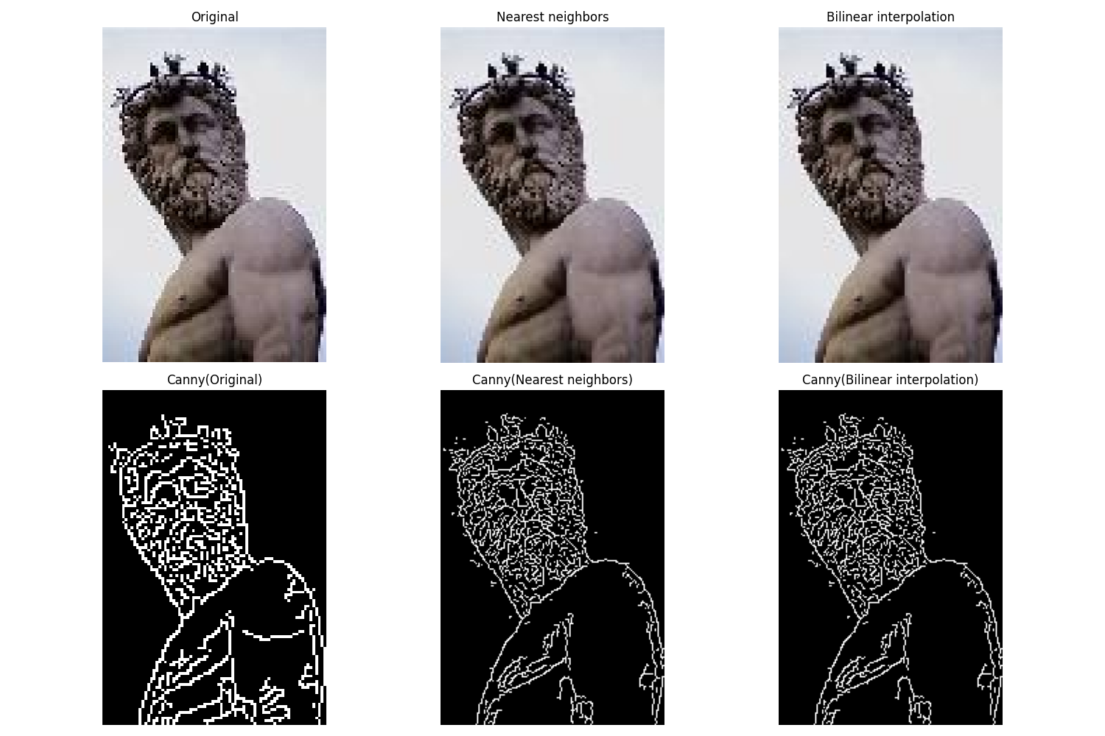

Nearest neighbors: 0.00 seconds

Bilinear interpolation: 0.01 seconds

## Scale: 500%

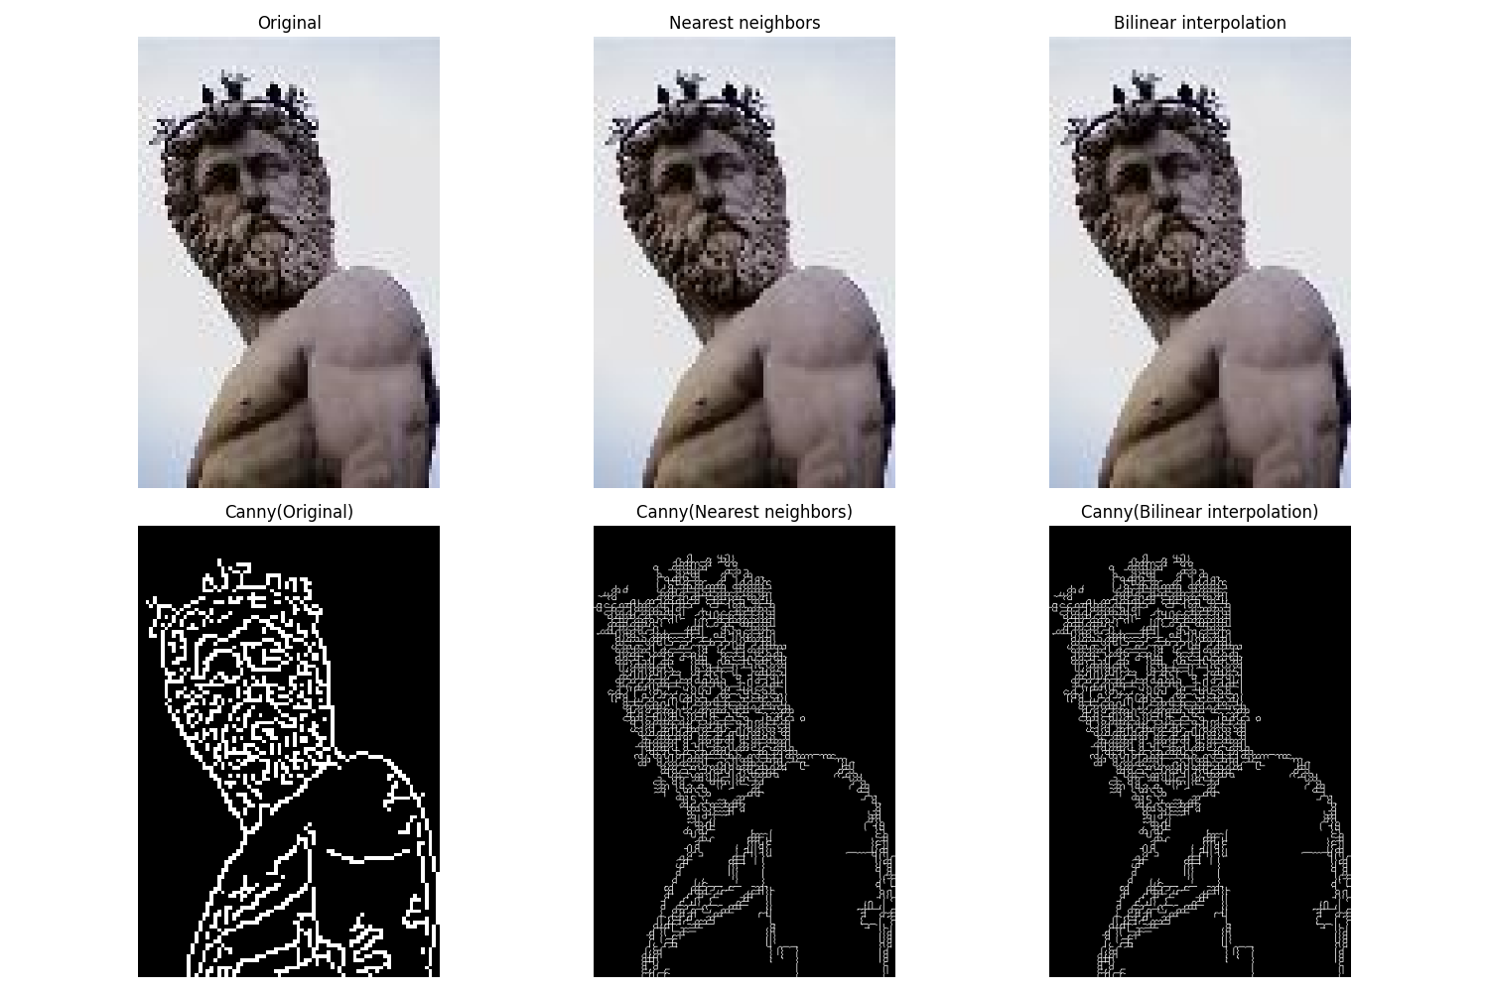

Nearest neighbors: 0.01 seconds

Bilinear interpolation: 0.07 seconds

## File: SMALL_0007.jpg

# Upscaling Results

## Scale: 200%

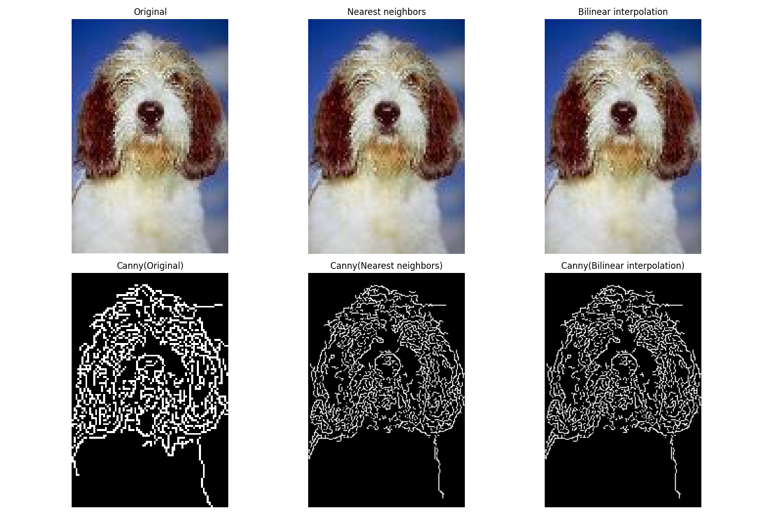

Nearest neighbors: 0.00 seconds

Bilinear interpolation: 0.01 seconds

## Scale: 500%

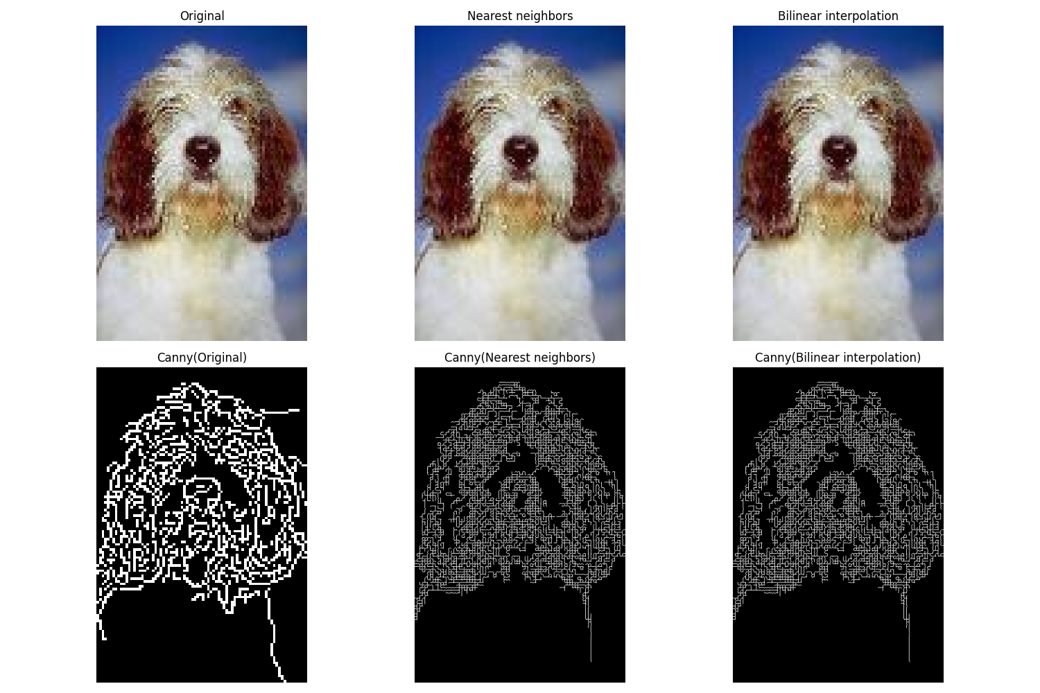

Nearest neighbors: 0.02 seconds

Bilinear interpolation: 0.07 seconds

## File: SMALL_0009.jpg

# Upscaling Results

## Scale: 200%

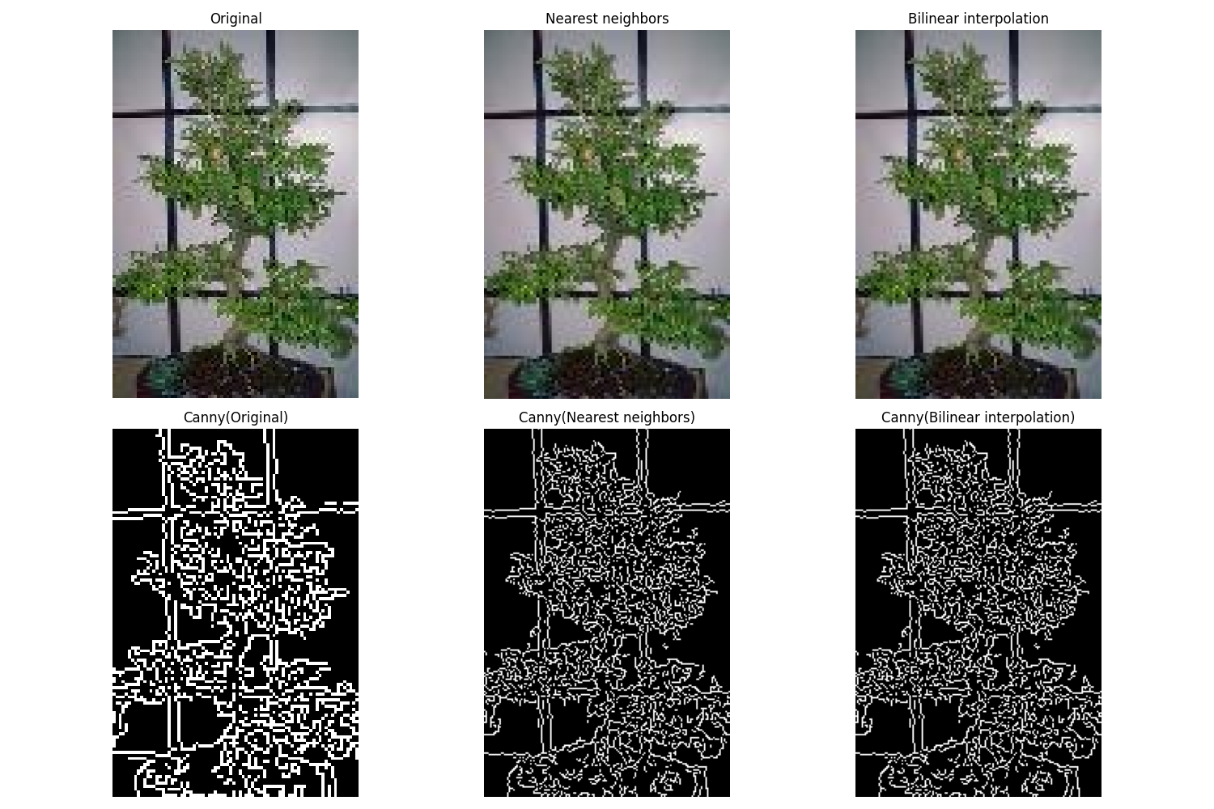

Nearest neighbors: 0.00 seconds

Bilinear interpolation: 0.01 seconds

## Scale: 500%

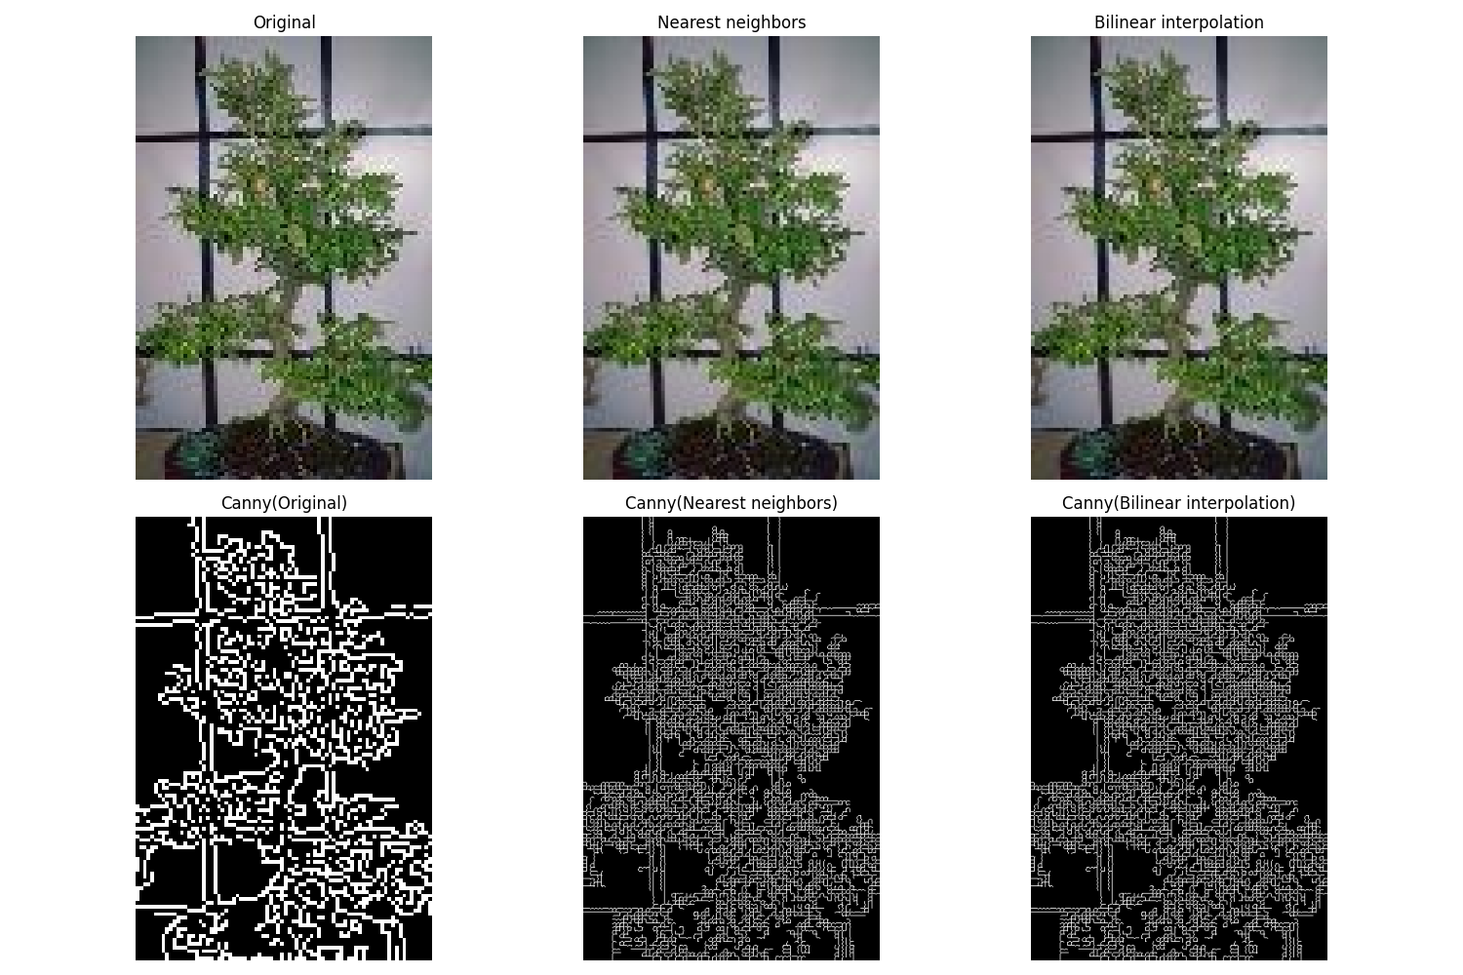

Nearest neighbors: 0.02 seconds

Bilinear interpolation: 0.06 seconds